Installation Example of DI-206 with Telstra Bigpond OnRamp2 line and single user account
Author: Steven Sia
Version: 1.1
Date: 8/9/2000

IMPORTANT:
- DI-206 firmware has to be ver 1.85 or later.
- Installation program Routeman has to be ver 1.20.11 or later
- All these are available from http://www.dlink.com.au/tech/drivers/files/routers/di206.htm

- Install Routeman and run it.
- Click on “Discovery” and wait for DI-206 to be discovered.
- Set an unused IP address for DI-206 in “Set IP” and then click on the “Pencil” icon (at the bottom) to write into DI-206.

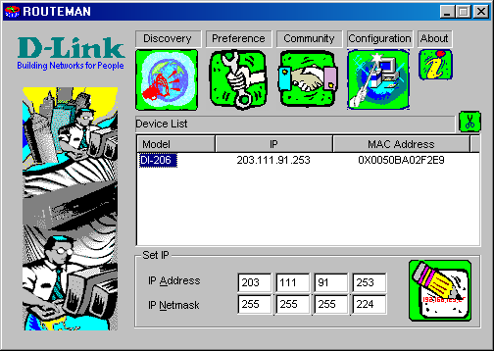
- Double-click on “DI-206” OR click on “Configuration” button. Enter your password (Default is Admin). Your default browser will be started up with the following Main Page for configuring DI-206.

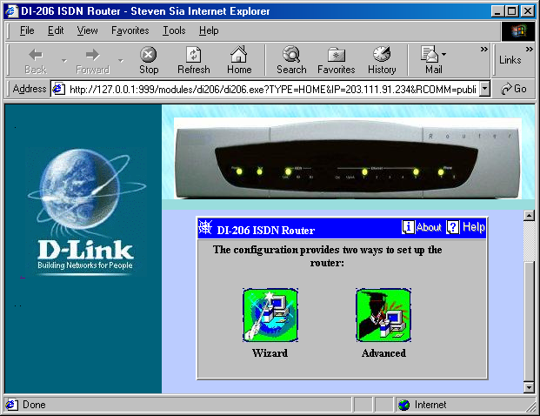
- Click on “Wizard” to start the setup wizard.

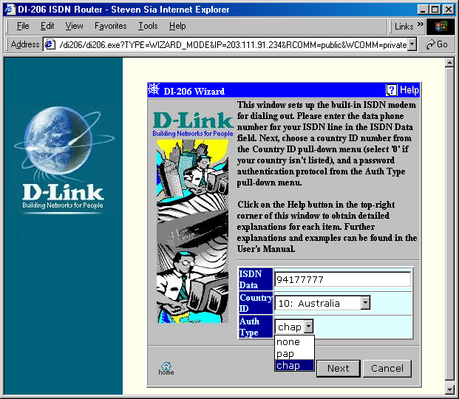
“ISDN Data” is your ISDN line tel. number at this premise
“Country ID” = 26 for NewZealand
“Auth Type” = chap depending on what your ISP supports.
- Click “Next” to continue.

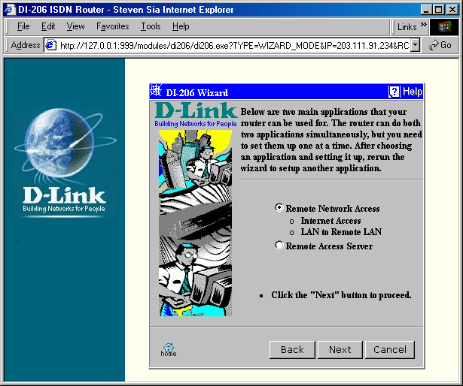

- In this example, we are setting it up for Internet Access so select “Remote Network Access”.
- Click “Next” to continue

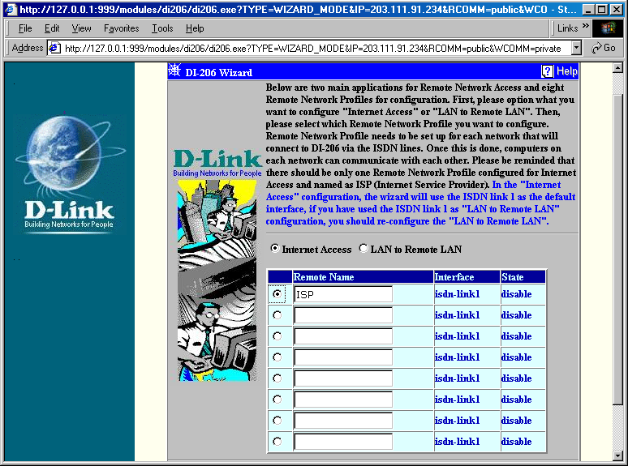
- We select ISP in this example. Please note that ISDN link 1 will be used for Internet Access.
- When done, Click “Next” to continue.

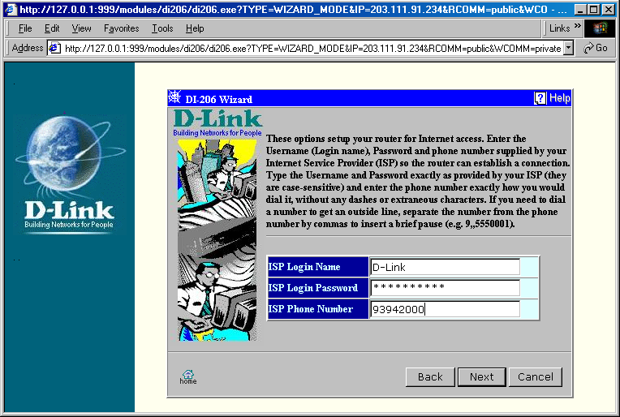
- Enter your account details from your ISP above.
- Click “Next” to continue

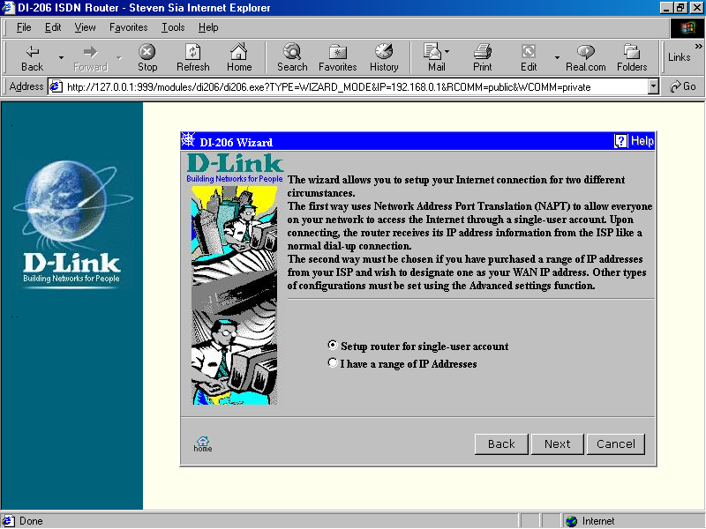
In this example, we are using an end-user ISDN Internet account (NOT a corporate account with range of public IP addresses).
- So, select “Setup router for single-user account”.
- Click “Next” to continue.

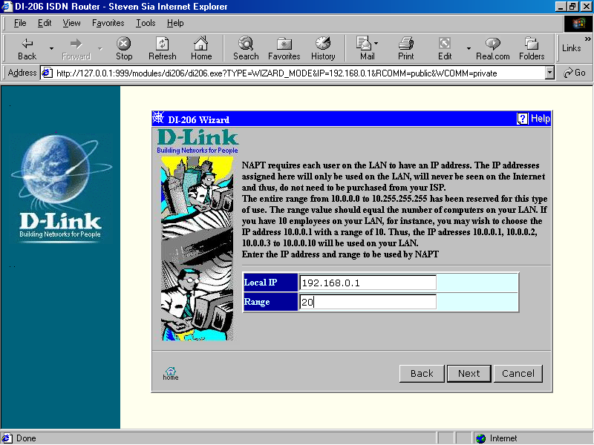
- Enter the range of your local IP addresses here. For this case, there are less than 20 machines/equipment in this network.
- Click “Next” to continue.
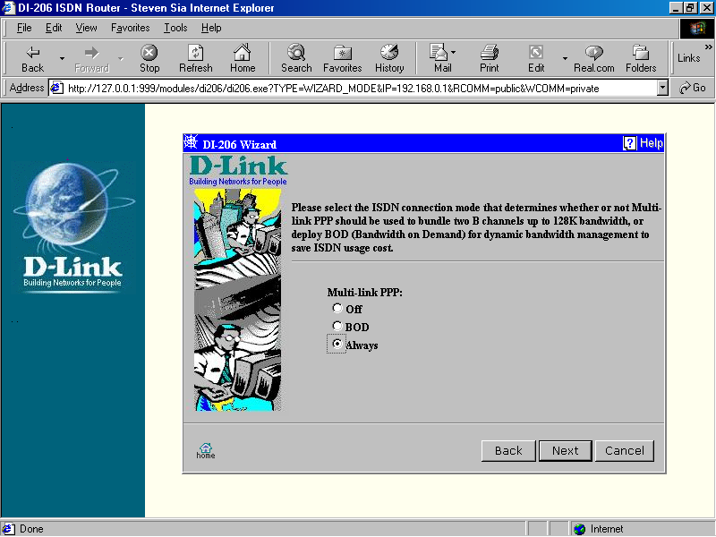
Select Multi-link PPP to be
“Off” if you only want to use 64kbps;
“Always” for 128kbps;
“BOD” for Bandwidth On Demand, i.e. the 2nd B-channel will be fired/hung up as and when it is needed/not needed.

- In this example, “Always” is selected because 128kbps is required.
- Click “Next” to continue.

- After that, a summary of the router setup details you have entered will be shown.
- Click on “Finish” and your basic essential setup has been done and saved into the router! Now…

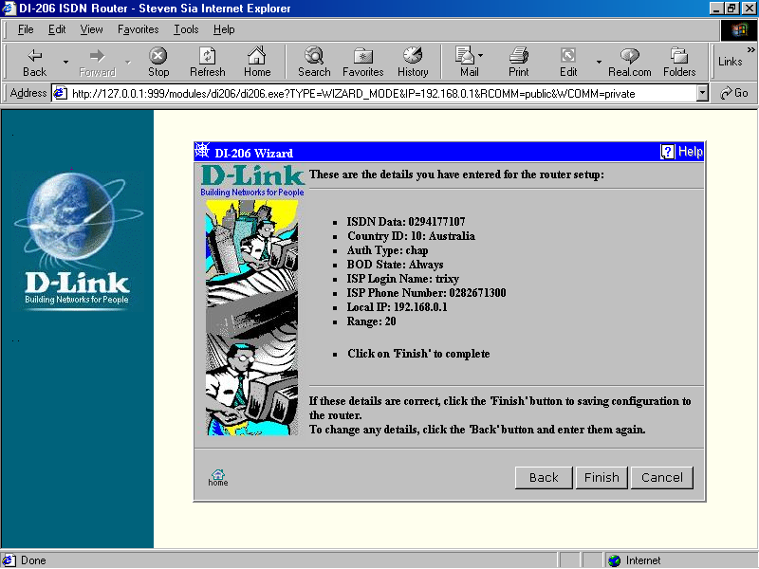
- Select “Return to the main page.
- Click “OK”.

We will not recommend user to set up any advanced features without understanding the application of it. Please consult your network administrator/consultant before carrying on. If you wish to set more Advanced features, just click on Advanced button on the Main Page. Make sure you have a good idea on what advanced features your network needs.

For this case, we only need to change ONE settings in “Advanced”
- Click on “Advanced”

- Click on “ISDN”
- Click on “IP Configuration”

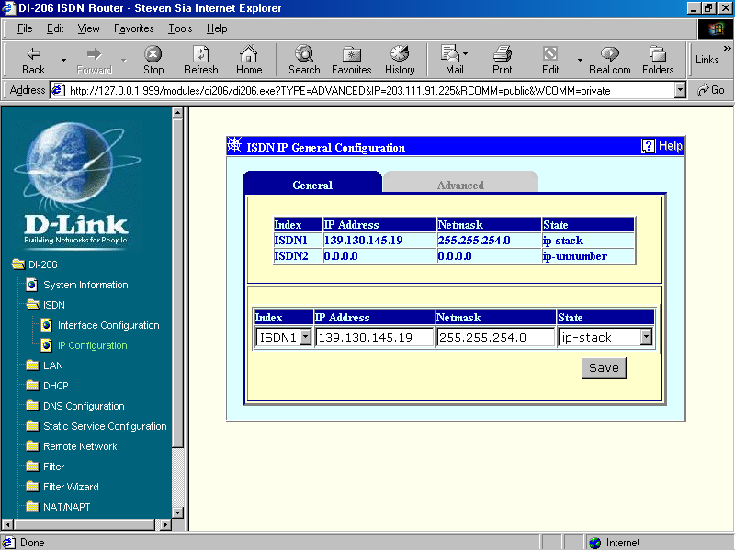
- Select “Index” = ISDN1
- Enter “IP Address” = Your end BPD IP address (as given by Bigpond) = 139.130.145.19 (example)
- Enter “Netmask” = Your end BPD Subnet Mask (given by Bigpond too) = 255.255.254.0 (example)
- Select “State” = ip-stack

- ** CLICK ON “SAVE” button to save it.

You do not have to worry about ISDN2, just leave it as it is.

- Close all windows and power off the router.
- Plug in the ISDN line into ISDN port and all the cables to PCs and/or hub/switch.
- Power the router on.
- After the Power-On-Self-Test, you have to setup every PC as below:
- IP address = individual IP address for each PC (eg. 192.168.0.2, 192.168.0.3, and so on)
- Default Gateway = DI-206 IP address (eg. 192.168.0.1)
- DNS enabled = DNS given by your ISP

Thank you very much for reading the document. If you have any feedback or further queries, please feel free to email your comments to support@dlink.com.au. Thank you.

