Installation shots v1.1
Changes –
Completed recommendations for Re-Write of second screen to be more user friendly and less confusing.

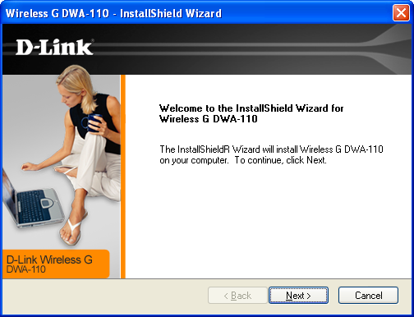
Typo on InstallShield -> InstallShieldR

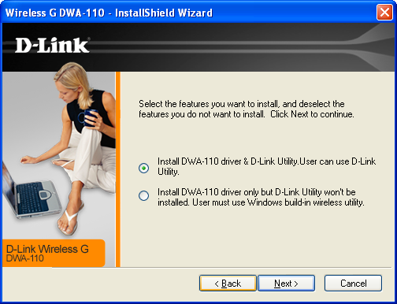
This page can be confusing for customers and is very impersonal
Recommendation for rewrite :

Select the wireless utility you prefer to manage your wireless card

Install and use D-Link Wireless Utility to manage your wireless card (Recommended)

Use Native Windows XP wireless utility to manage your wireless card

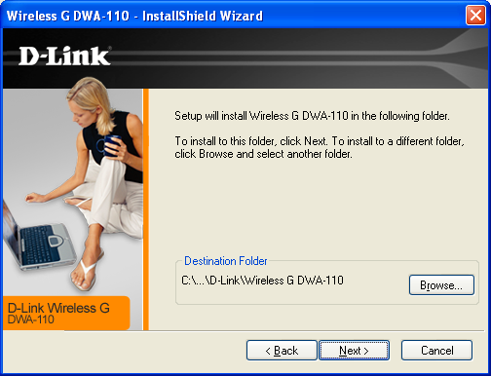
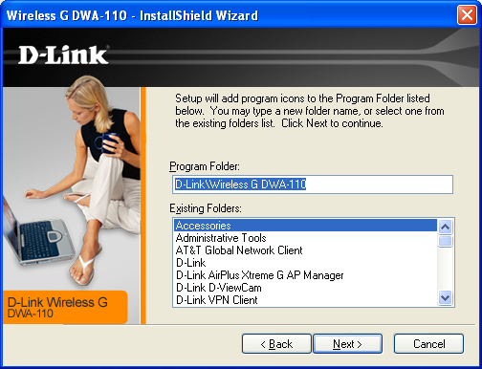
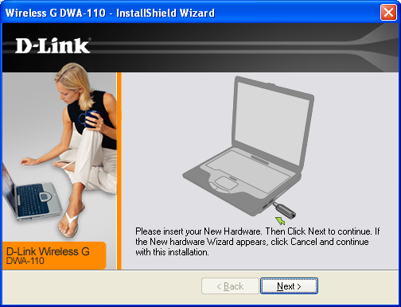
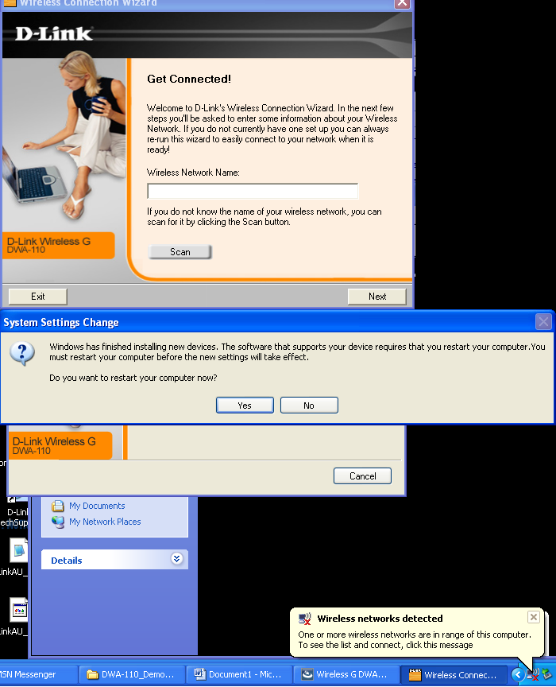
The add new hardware wizard screen that the setup warns about did not appear on my computer – unknown if other machines will have the same issue.

This screen will be a problem with users rebooting before they have configured their wireless settings – users will need to open wireless utility upon reboot and configure their connections manually.

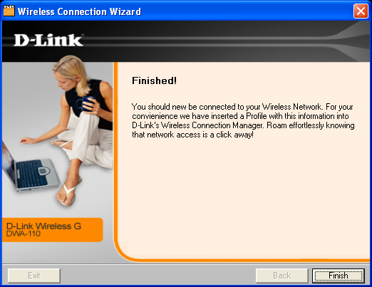

You should NOW – instead of you should NEW
